Serving static assets
Although our app is functional, it isn’t much to look at. We can improve that with some static assets such as images, CSS or a bit of JavaScript.
Go Fiber has methods to help us achieve this fairly easily. Let’s head back into our main.go file and use the app.Static method to tell our app where to locate our static assets. In our case, we will be putting our images, CSS and JS in a folder called public. We have chosen to call it public because its somewhat of a convention, but you can call this folder anything you like.
1  2  3  4  5  6  7  8  9  10  11  12  13  14  15  16  17  18  19  20  21  22  23  24 | package main  import (  "github.com/gofiber/fiber/v2"  "github.com/gofiber/template/html"  "github.com/divrhino/divrhino-trivia/database"  )  func main() {  database.ConnectDb()  engine := html.New("./views", ".html")  app := fiber.New(fiber.Config{  Views: engine,  ViewsLayout: "layouts/main",  })  setUpRoutes(app)  app.Static("/", "./public")  app.Listen(":3000")  }
The public folder does not exist yet, so let’s create it in the root of our project
1 | mkdir public
Now we can move on and adding our logo image.
Images
To keep our images organised, we will create a folder in our public directory called image:
1 | mkdir public/image
We can put our logo image file into this folder.
Our logo image is now present in the header on our index page. If we visit other pages, the header partial is also present.
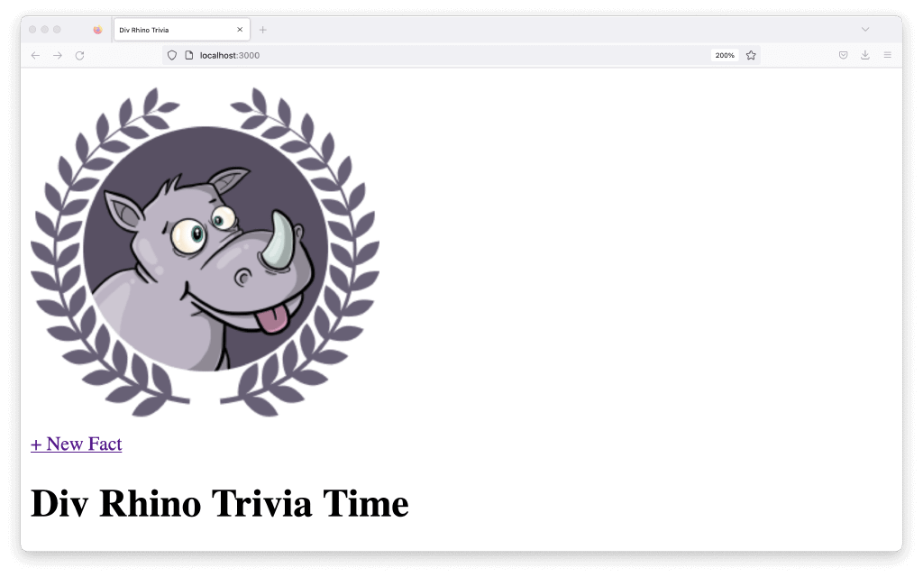
Linking stylesheets
Apart from images, we can also add some CSS stylesheets.
To keep our stylesheets organised, let’s create a folder in our public directory called style:
1 | mkdir public/style
Then we can create a stylesheet within it:
1 | touch public/style/main.css
We don’t have anything in our main.css file yet, but let’s link it in our head tag first and add some styles later. In the main layout, we can add this link tag to the <head>. We’ve added a query param of v=1 after the href value as a rudimentary way to bust the cache while we’re developing, locally. I’m sure there are other ways to do this.
1 | <link rel="stylesheet" href="style/main.css?v=1">
Let’s also add the viewport meta tag to the <head> so our app can be responsive and display correctly on mobile devices:
1 | <meta name="viewport" content="width=device-width,initial-scale=1">
The index.html template should look like this:
1  2  3  4  5  6  7  8  9  10  11  12  13  14  15  16  17  18 | <!DOCTYPE html>  <head>  <title>Div Rhino Trivia</title>  <meta name="viewport" content="width=device-width,initial-scale=1">  <link rel="stylesheet" href="style/main.css?=1">  </head>  <body>  <div class="wrapper">  {{template "header" .}}  <h1>{{.Title}}</h1>  <h2>  {{.Subtitle}}  </h2>  {{embed}}  </div>  </body>  </html>
Inside our main.css file, we can change the body element’s background colour
1  2  3 | body {  background-color: aquamarine;  }
We will have to update our markup and paste in some pre-prepared styles. We will not go over the specifics here, as this is not a CSS tutorial. But the completed markup and stylesheet can be found in the Github repo.
JavaScript
We’ve added a bit more markup to make the layout a little more interesting. We’ve added a little toggle button next to each of our facts.
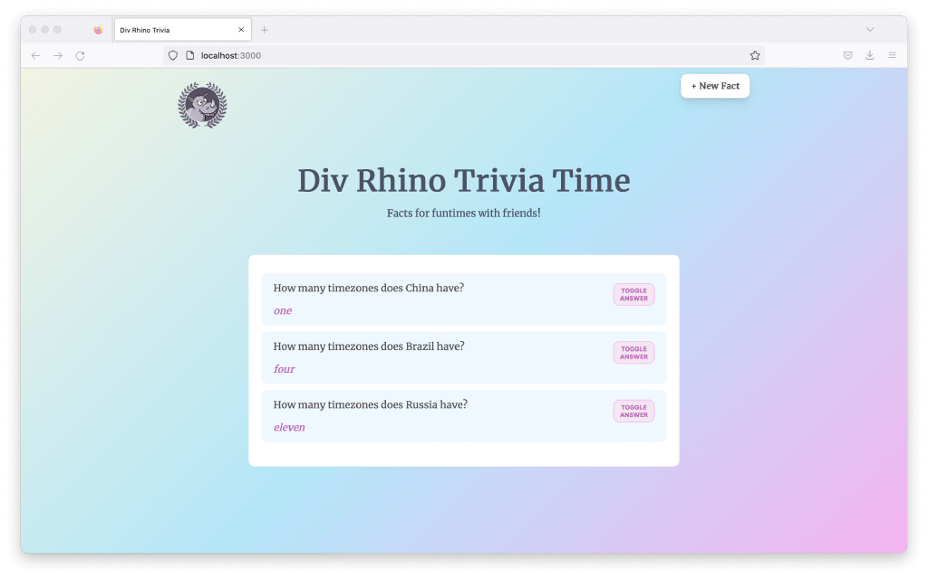
Right now, they are not functional. Let’s add some javascript to make these buttons interactive.
To keep our JavaScript organised, let’s create a folder in our public directory called javascript:
1 | mkdir public/javascript
Then we can create a JavaScript file within it:
1 | touch public/javascript/app.js
We don’t have anything in our app.js file yet, but let’s link it in our head tag first and add our JS later. In the index.html view, we can import this <script> tag at the bottom of the file.

1  2  3  4  5  6  7  8  9  10  11  12  13  14  15  16  17  18  19  20  21  22 | <div class="container">  {{if .Facts}}  {{ range .Facts }}  <div class="fact-item">  <div class="question-wrapper">  <p class="question">{{ .Question }}</p>  <button id="answer-toggle" class="answer-toggle">Toggle answer</button>  </div>  <div class="answer-wrapper">  <p class="answer">{{.Answer}}</p>  </div>  </div>  {{ end }}  {{else}}  <div class="no-facts">  <p>No facts yet.</p>  <p><a href="/fact">Add new</a></p>  </div>  {{end}}  </div>  <script src="/javascript/app.js"></script>

We will also paste in some pre-prepared JS. Again, the final javascript file can be found in the Github repo.
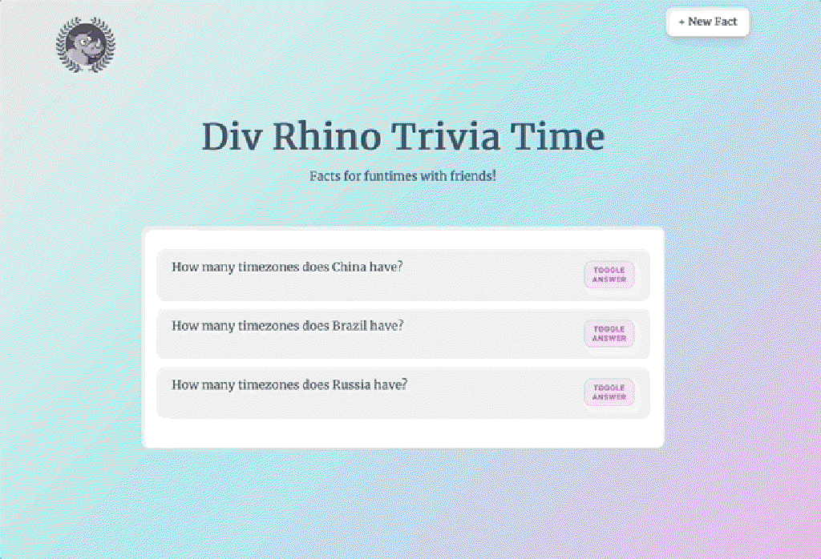
And with that, we’ve come to the end.

Conclusion
In this tutorial we learnt how to add a form and other frontend views to a Go Fiber app that was build from scratch using Go and Docker. We started with a simple API and extended it to include templates and static assets.
Congratulations, you did great! Keep learning and keep coding. Bye for now, <3.

Related articles
- Create a CRUD app with Go Fiber, docker, and Postgres
- Build a REST API from scratch with Go, Docker & Postgres
- Building an interactive CLI app with Go, Cobra & promptui

